**Ethical Hacking & Security Assignment CT5049**

**Ethical Hacking Methodology Report**

Sravanthi Dharmaprakash

S4215674

TABLE OF CONTENTS

Introduction 4

Part 1 - Discovered Vulnerabilities 4

Scanning and Enumeration 4

Flag 1- 3a385ac07dcec4dde1a4ca47a9802c96 8

Flag 2 12

Flag 3 ( letter{7ff135854376850e9711bd75ce942e07}) 13

Part 2 – Maintaining Access and Hiding Tracks (This can 19

Maintaining Access 19

Hiding Tracks 19

Flag 4 24

Part 3 - Introducing Protection Mechanisms 26

Vulnerability 1: 26

PhpMyAdmin- 26

Vulnerability 2: 26

CVE-2019-9517: A denial-of-service (DoS) vulnerability in HTTP/2. 26

Conclusion 27

References 29

TABLE OF FIGURES

Figure 1: Nmap Scan showing open ports on 192.168.56.159 5

Figure 2: Nmap -p80 -A 192.168.56.159 to get the Version, http title, http server-header. 6

Figure 3: Running - -scripts to find CVE-2019-9517: 7

Figure 4: Finding Directories and files within ‘dirb’ 7

Figure 5: Flag 1 retrieved with wpscan 8

Figure 6: Found phpMyAdmin as a vulnerability for the next steps to finding flag 8

Figure 7: Searching for phpMyAdmin exploits 10

Figure 8: phpmyadmin_preg_replace is not vulnerable- exploit failed 11

Figure 9: Showing 192.168.56.159:5555 for arriving at Wordpress scan /wp-admin 12

Figure 10: Version of WordPress is Insecure Found by Passive Detection 13

Figure 11: Shows Users and their Passwords- David and password Hash 14

Figure 20: Patient names with Flag 3 15

Figure 12: Vulnerabilities found in WordPress Plugins- 16

Figure 13: Illustrating the wide range of exploits present for WordPress Plugins 17

Figure 11: PHPMYADMIN exploits found- 17

Figure 14: PhpMyAdmin and SQL Injections seen in search function under metasploit 18

Figure 15: Three Important Exploits found which potentially have the flags- 19

Figure 16: Important Vulnerabilities to be seen 22

Figure. 12: Important Vulnerabilities and Exploits can be seen 22

Figure 13: Searches in Metasploit 22

Figure 18: Attempts to Search for Flag4 - 24

Figure 19: Successfully scanned for SQL injection vulnerabilities 25

# Introduction

The report presents findings from an ethical hacking assessment conducted on the Fernwood Clinic’s virtual machine (TOE), aiming to identify and exploit vulnerabilities within the system ethically. The assessment followed a structured approach, including reconnaissance, vulnerability assessment, exploitation, post-exploitation, and covering tracks (Saraswathi et al., 2022).

* **Reconnaissance**: Initial reconnaissance revealed open ports and services running on the target IP address 192.168.56.159, including Apache HTTP servers and a Webmin interface (Saraswathi et al., 2022).
* **Vulnerability Assessment**: Vulnerability assessment identified key weaknesses such as an HTTP/2 Denial-of-Service vulnerability (CVE-2019-9517) and a SQL injection vulnerability (Anchugam, 2021).
* **Exploitation:** Identified vulnerabilities were exploited using tools like Metasploit and SQLMAP to gain unauthorized access to the TOE (Kaur et al., 2024).
* **Post-Exploitation:** Post-exploitation activities focused on maintaining access and escalating privileges within the TOE, including installing backdoors and exploiting misconfigurations (Kaur et al., 2024).
* **Covering Tracks:** Efforts were made to cover tracks by deleting logs and hiding login attempts to minimize detection (Kaur et al., 2024).

Throughout the assessment, ethical guidelines and legal requirements were strictly followed, ensuring compliance and minimizing disruption to normal operations (Kaur et al., 2024).

# Part 1 - Discovered Vulnerabilities

## Scanning and Enumeration

The Nmap scan report contains information's about the services running on the host with IP address 192.168.56.159. The findings are as follows:

1. **Host information:** 
   * **IP Address:** 192.168.56.159
   * **Latency:** The host is up with a latency of 0.0060 seconds
2. **Open TCP Ports and Service:** 
   * **Port 80 (HTTP):** It is in the version Apache httpd 2.4.29 running on Ubuntu.This http page has the title “Sapphire IT Requests – External Support”
     1. **Supported Methods:** GET, HEAD, POST, OPTIONS
     2. **Server Header:** Apache/2.4.29 (Ubuntu)
   * **Port 5555 (HTTP):** It is in the version Apache httpd 2.4.29 running on Ubuntu. This http page has the title “Fernwood Medical Centre – WEBSITE UNDER DEVELOPMENT”
   * **Port 1000 (HTTP):** It is in the version MiniServ 1.900 running on Webmin server. This http “Login to Webmin”. This contains 1 disallowed entry- “Robots.txt”.

**This interprets for-**

* **Port 80:** This port is serving a web application titled “Sapphire IT Requests- External Support”. It is running on Apache 2.4.29. The methods supported (GET, HEAD, POST, OPTIONS) indicate potential interaction points for web-based attacks like SQL injection, XSS or CSRF.
* **Port 5555:** This port is also serving a web application, specifically for a “Fernwood Medical Centre” under development, using WordPress 6.5.3. Since it’s a WordPress site, it might be vulnerable to common WordPress exploits, outdated plugins, or themes.
* **Port 10000:** This port is running Webmin, a web-based interface for system administration, specifically version 1.900. The login page might be susceptible to brute-force attacks or known vulnerabilities associated with this version of Webmin.
* **Robots.txt:** The disallowed entry in the robots.txt file (“/”) might indicate that web crawlers are discouraged from indexing the entire site. This might be useful for enumeration and could lead to hidden or sensitive directories.

This IP was found to be a private address of RFC 1918 and in a reserved range or also known as non-routable range (Rekhter *et al.*, 1996)

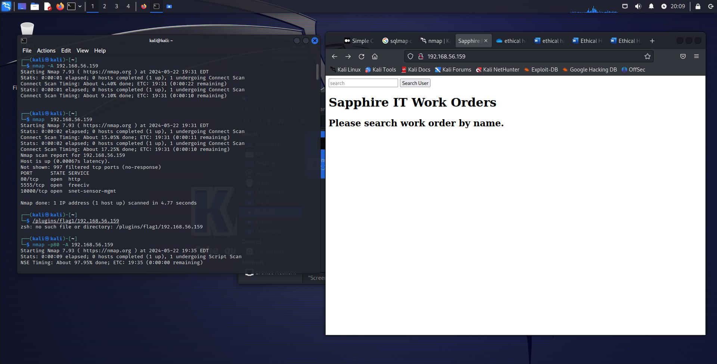

### Figure 1: Nmap Scan showing open ports on 192.168.56.159

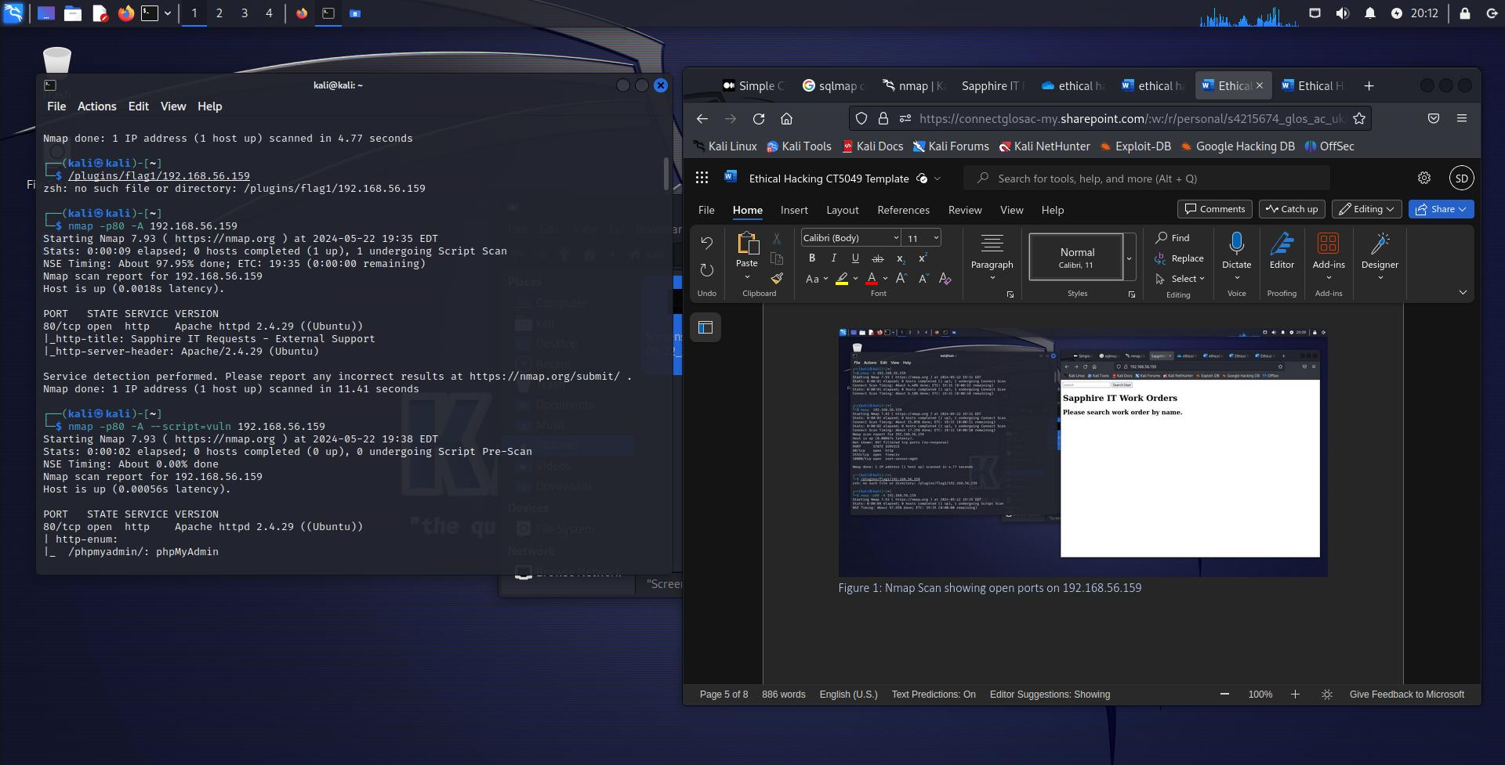

### Figure 2: Nmap -p80 -A 192.168.56.159 to get the Version, http title, http server-header.

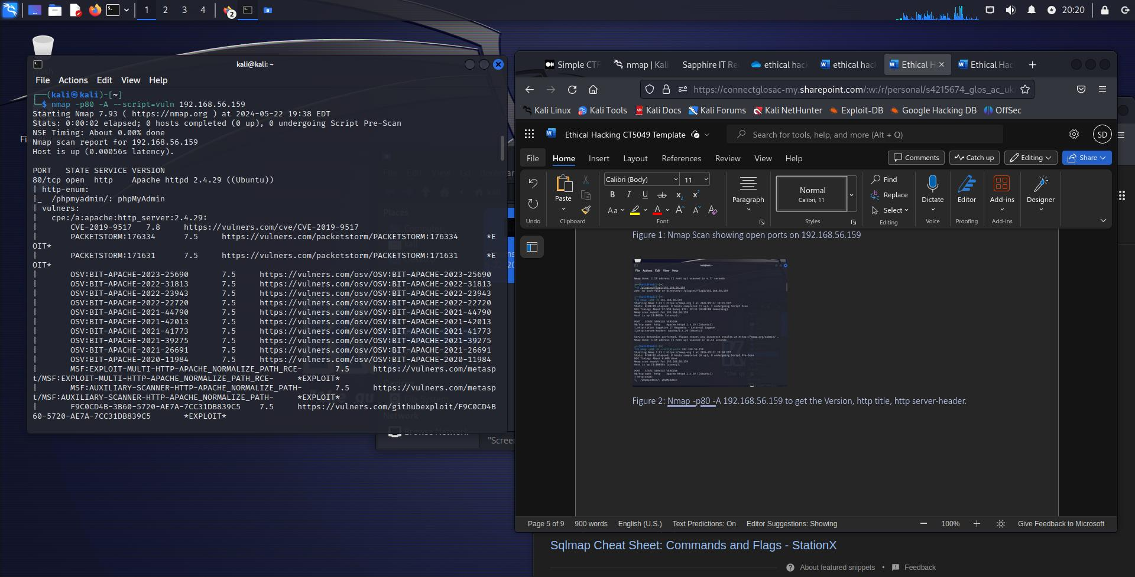

### Figure 3: Running - -scripts to find CVE-2019-9517:

A denial-of-service (DoS) vulnerability in HTTP/2 with several others in port 80 (NVD - CVE-2019-9517, n.d.).

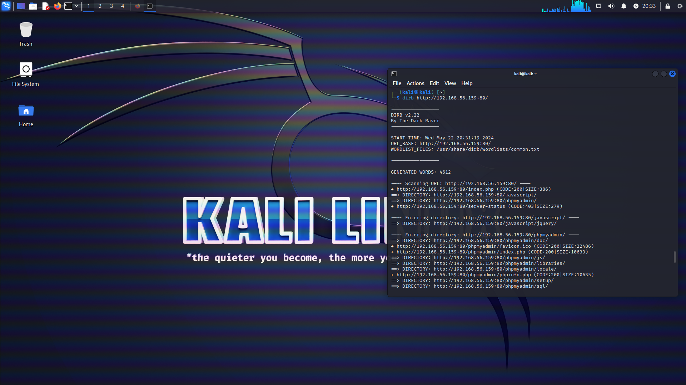

### Figure 4: Finding Directories and files within ‘dirb’

# Flag 1**- 3a385ac07dcec4dde1a4ca47a9802c96**

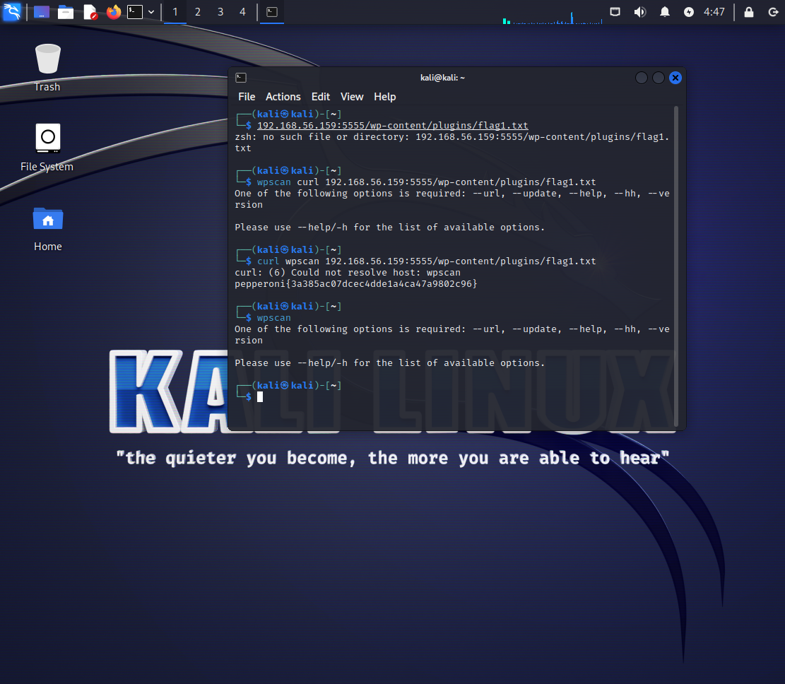

### Figure 5: Flag 1 retrieved with wpscan

The figure above shows wpscan the command curl wpscan 192.168.56.159:5555/wp-content/plugins/flag1.txt - gathering information showing the presence of a vulnerability to retrieve the flag indicating a successful exploitation.

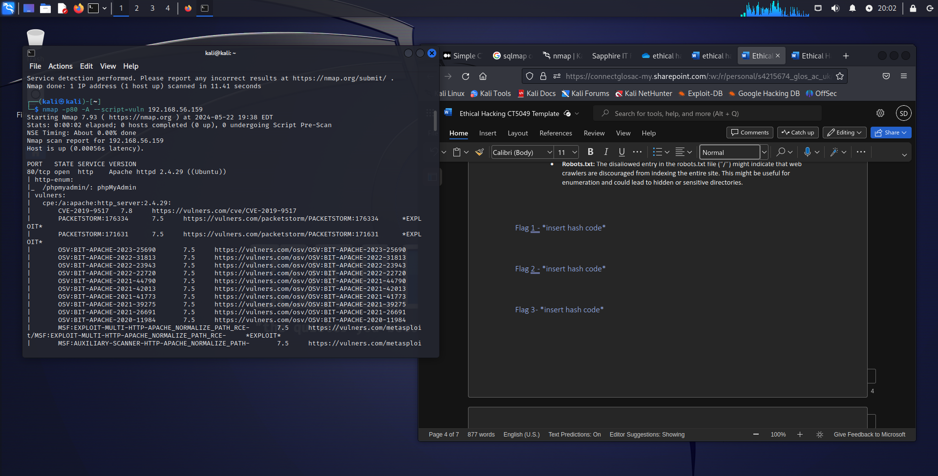

### Figure 6: Found phpMyAdmin as a vulnerability for the next steps to finding flag

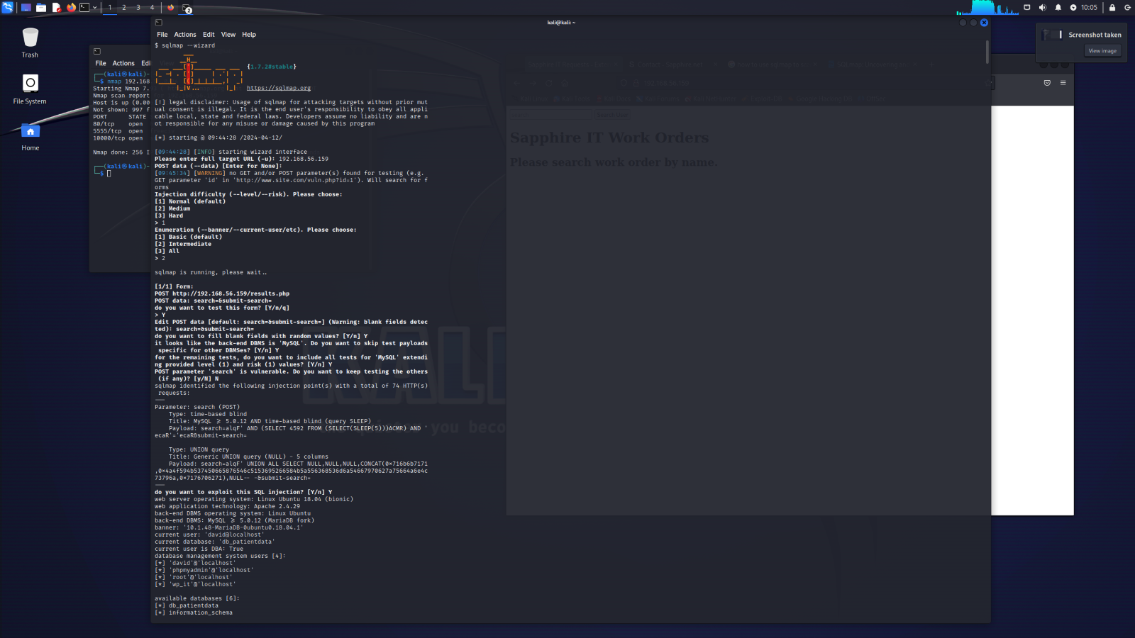  
  
Figure 6: SQL Map for automated SQL injection and database takeover for any injectable points (Gunawan et al., 2018) (Runtime Monitors to Detect and Prevent Union Query Based SQL Injection Attacks, 2013). This shows that the attacker has attempted to manipulate the structure of the SQL query to retrieve unintended data from a database (Runtime Monitors to Detect and Prevent Union Query Based SQL Injection Attacks, 2013). It can be prevented by properly sanitising or validating an input before it is being input to the SQL query (Runtime Monitors to Detect and Prevent Union Query Based SQL Injection Attacks, 2013). They might be able to attack the entire system with this as they can get easy access to the admins details as well, additionally limiting database permissions and implementing strict input validation can mitigate this risk (Runtime Monitors to Detect and Prevent Union Query Based SQL Injection Attacks, 2013) (Gunawan et al., 2018).

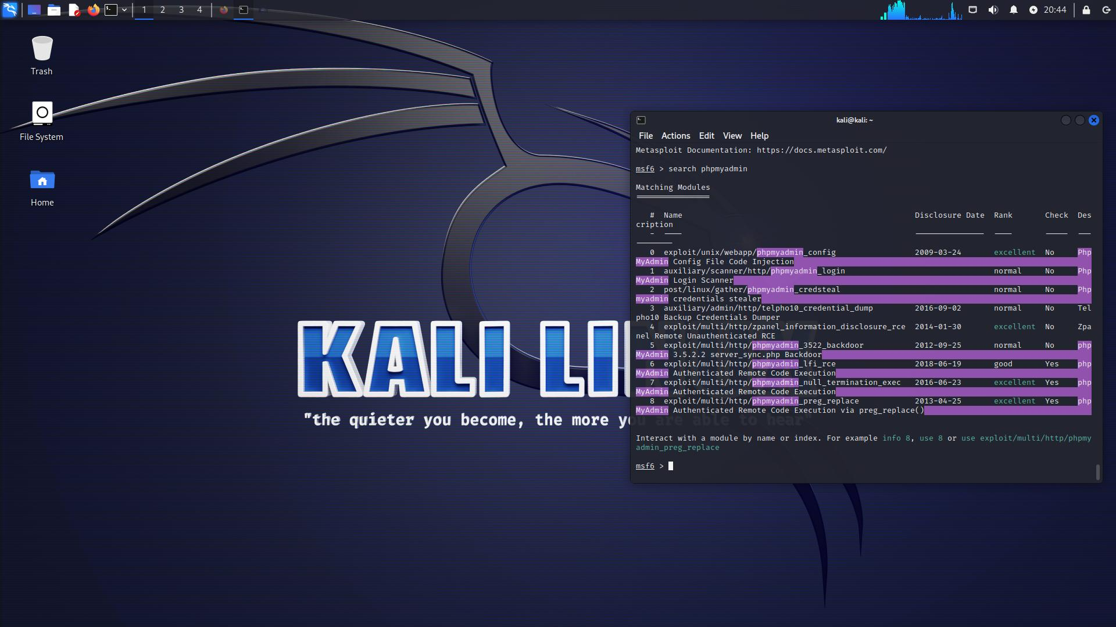

### Figure 7: Searching for phpMyAdmin exploits

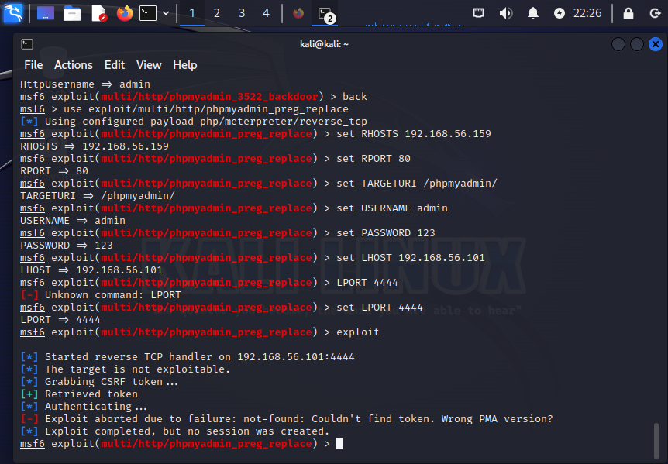

### Figure 8: phpmyadmin_preg_replace is not vulnerable- exploit failed

1. Initial Scanning and Enumeration:

* The ethical hacker or the consultant begins by identifying the phpMyAdmin service and its vulnerabilities using tools like `Nmap`, `dirb`, and `nikto` to conduct thorough scanning and enumeration.

1. Gaining Access with Metasploit:

* The ethical hacker uses `msfconsole` to run the `phpmyadmin_login` module for brute-forcing credentials.
* Upon obtaining valid credentials, the ethical hacker then utilizes the `phpmyadmin_preg_replace` module for Remote Code Execution (RCE) to gain shell access to the target system.

# Flag 2

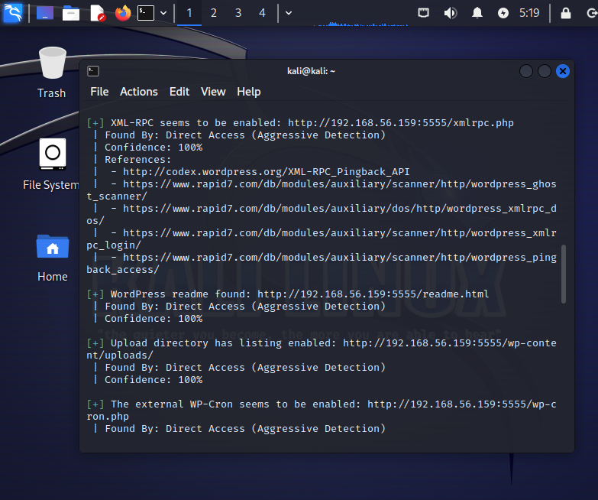

### Figure 9: Showing 192.168.56.159:5555 for arriving at Wordpress scan /wp-admin

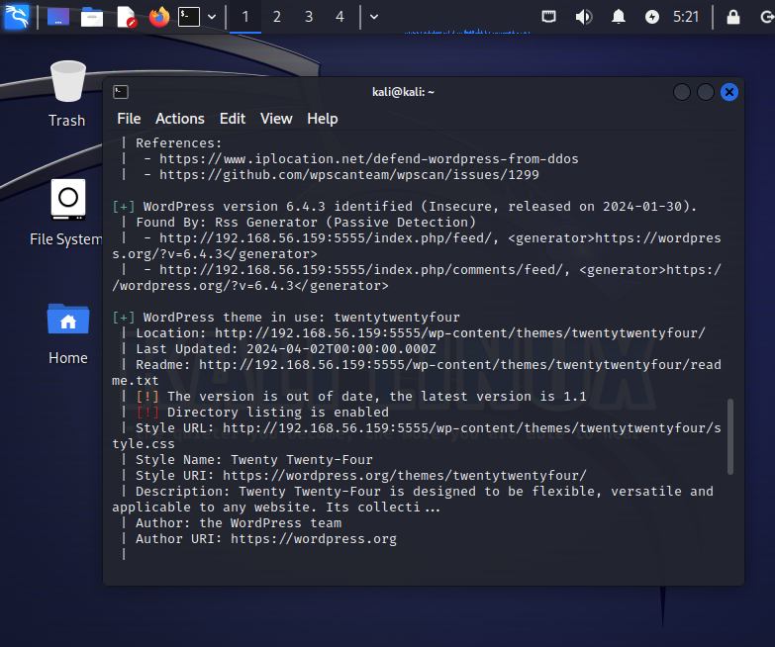

### Figure 10: Version of WordPress is Insecure Found by Passive Detection

# Flag 3 ( letter{7ff135854376850e9711bd75ce942e07})

SQL map performed by the hacker to find the third flag between Database: db_patientdata, when SQL map was run on Kali Linux machine using 192.168.56.159 of the clinic.

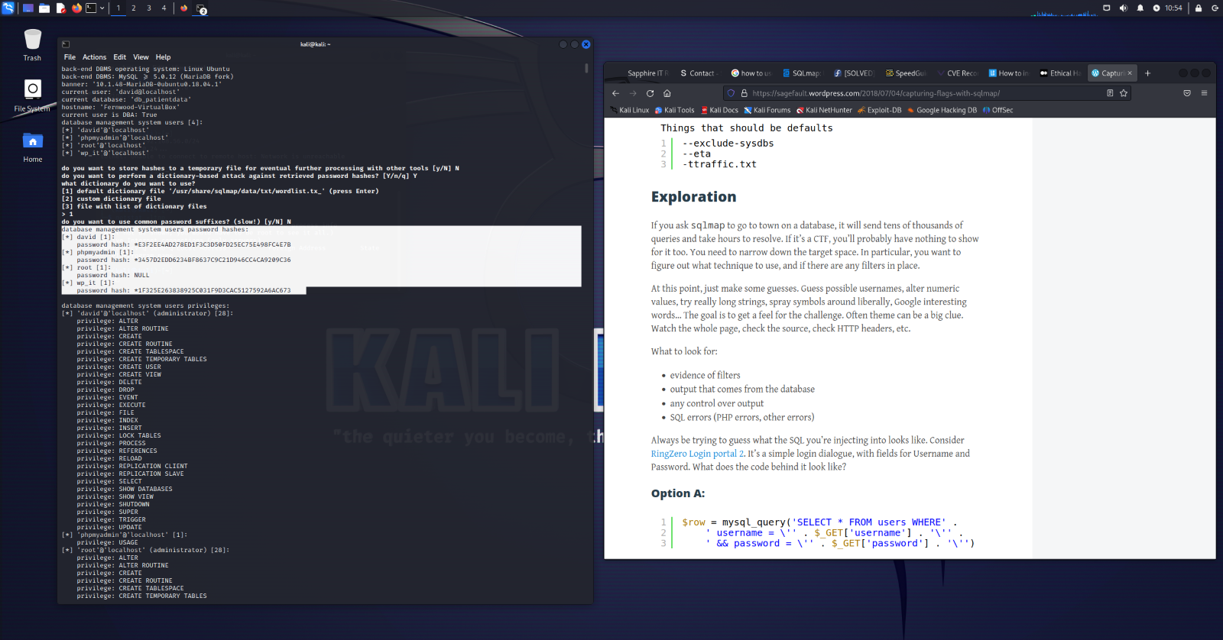

### Figure 11: Shows Users and their Passwords- David and password Hash

The injection and enumeration difficulty was set to a level 3 (Hard) by the consultant. The flag was under Patient_Name after scanning it through SQL map.

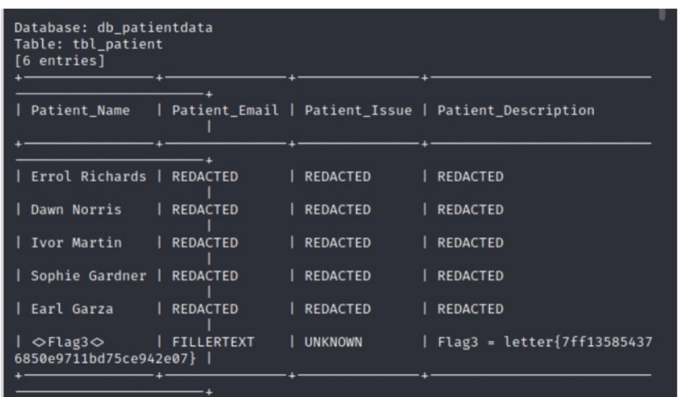

### Figure 20: Patient names with Flag 3

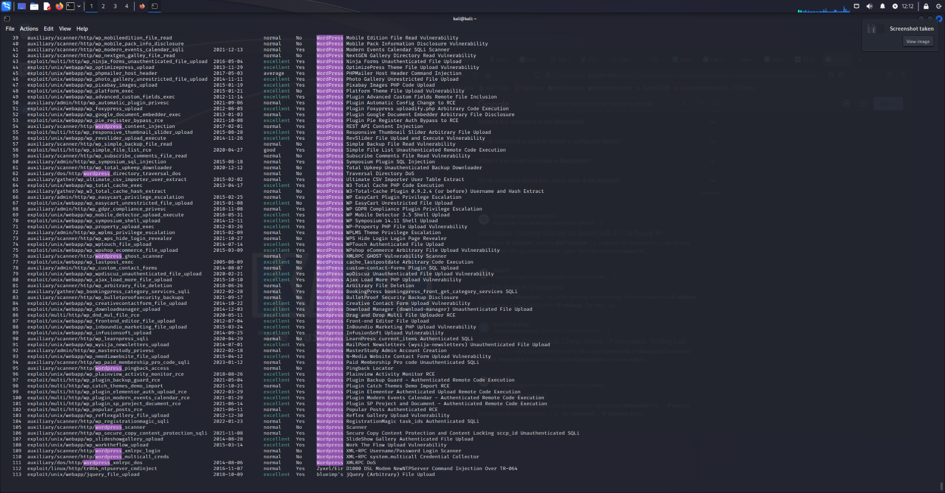

### Figure 12: Vulnerabilities found in WordPress Plugins-

Plugins found the main one being exploit/unix/webapp/wp_asset_manager_upload_exec from there the hacker gets the password and username (Bacardi and dave). The WordPress site with /wp-admin that hacker used had an admin page to access and the password was retrieved using social engineering techniques. Which was noticed to be a major vulnerability.

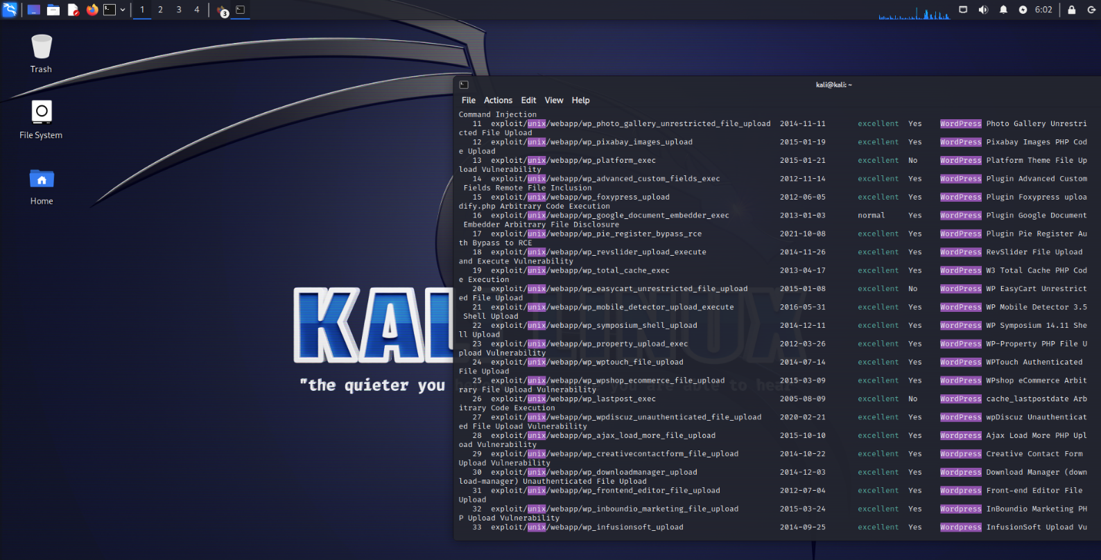

### Figure 13: Illustrating the wide range of exploits present for WordPress Plugins

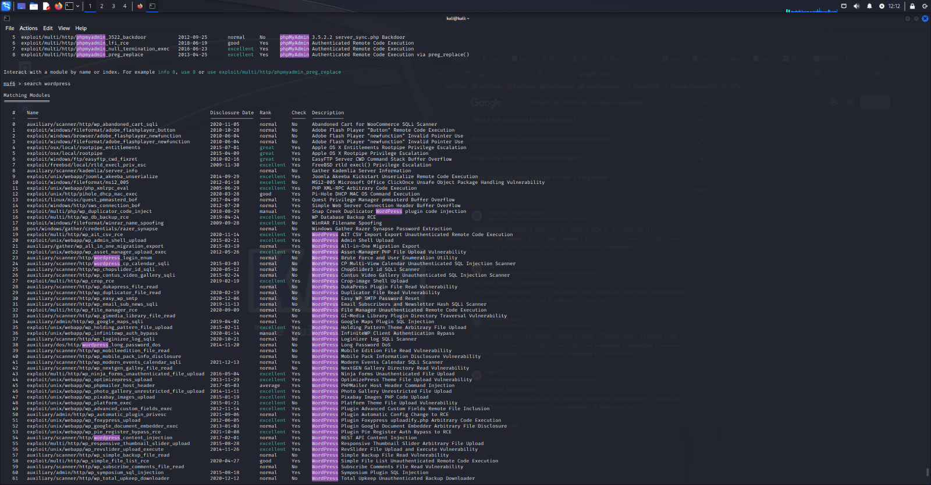

Figure 11: PHPMYADMIN exploits found-

Highlighted at the top, which have been attempted to exploit to find flags and vulnerabilities but resulted in errors due to Linux OS errors.

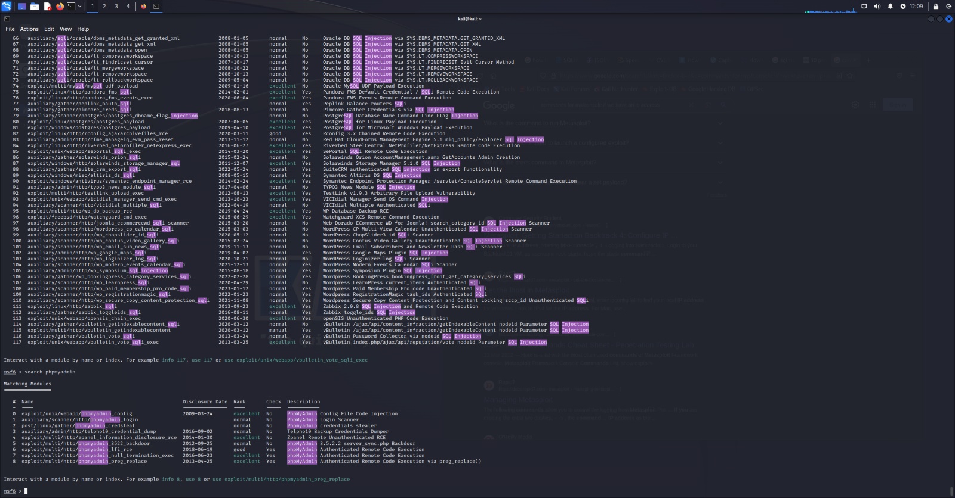

### Figure 14: PhpMyAdmin and SQL Injections seen in search function under metasploit

# Part 2 – Maintaining Access and Hiding Tracks (This can

## Maintaining Access

Once access is gained, maintaining access involves setting up persistent mechanisms to ensure continuous access. Techniques such as creating backdoor user accounts, installing persistent payloads, and leveraging cron jobs or scheduled tasks to reinitiate access if interrupted are commonly employed. The CVE exploit on Metasploit uses a payload to gain access to a system and establish a backdoor.

Once access is gained, maintaining access involves setting up persistent mechanisms to ensure continuous access. Techniques such as creating backdoor user accounts, installing persistent payloads, and leveraging cron jobs or scheduled tasks to reinitiate access if interrupted are commonly employed. The CVE exploit on Metasploit uses a payload to gain access to a system and establish a backdoor (CVE-2019-9517).

Payload command was performed after Metasploit (From Figure12) ,

* LHOST was given as the Kali machines IP Address- 192.168.56.101
* LPORT was given as 4444

## Hiding Tracks

Hiding tracks involves actions to erase evidence of the hacker’s presence. This can be achieved by deleting logs, clearing command history, and using rootkits to hide malicious processes. Specific commands in Unix-like systems such as shred for log files and history -c for command history are used to clean up traces of unauthorized access.

### Figure 15: Three Important Exploits found which potentially have the flags-

With the Description as- Advantech Network Command Injection, CVE-2020-1170 Cloud Filter File Creation, Docker Privileged Container Escape.

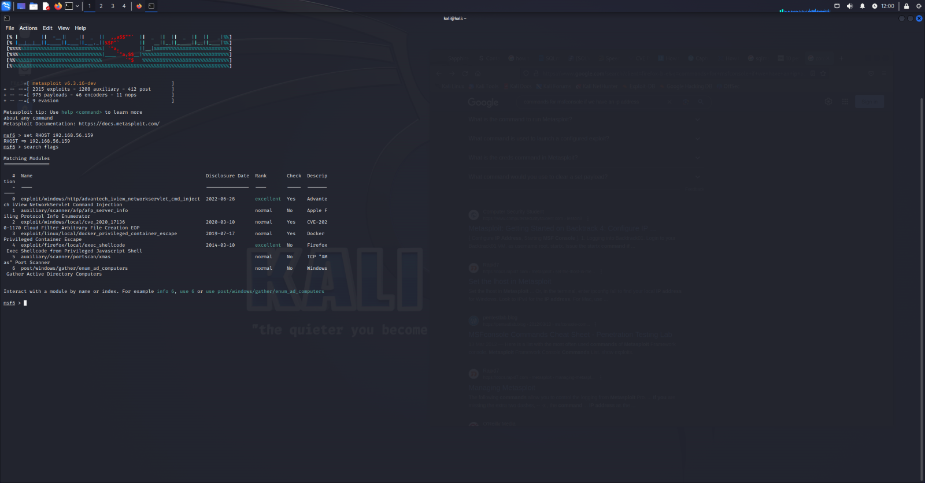  
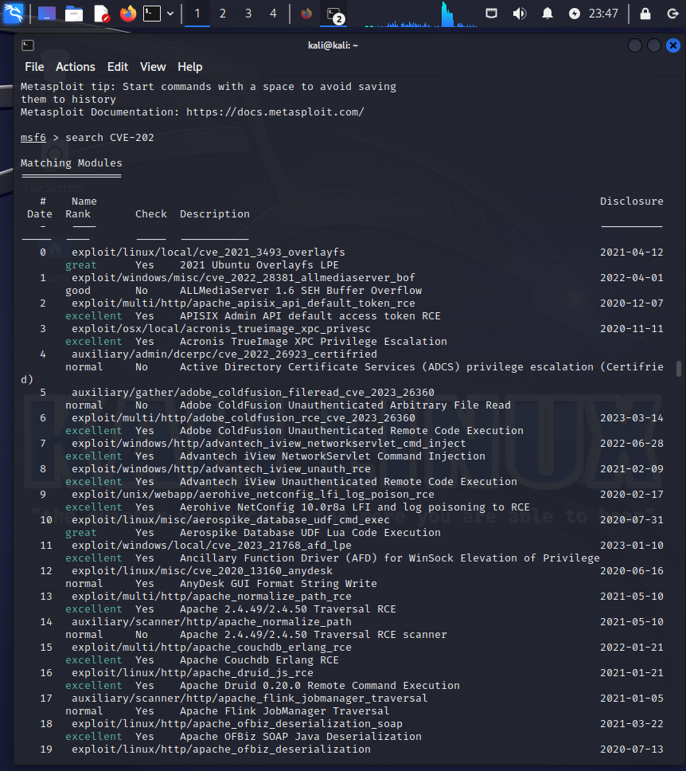

### Figure 16: Important Vulnerabilities to be seen

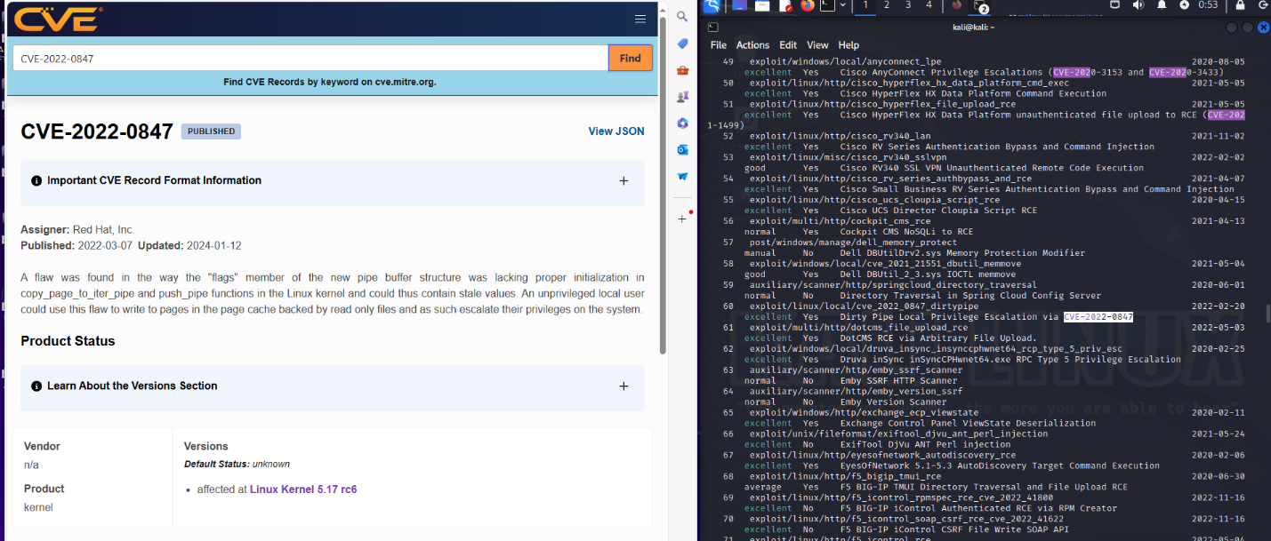  
  
Figure 17: Vulnerability CVE-2022-0847

### Figure. 12: Important Vulnerabilities and Exploits can be seen

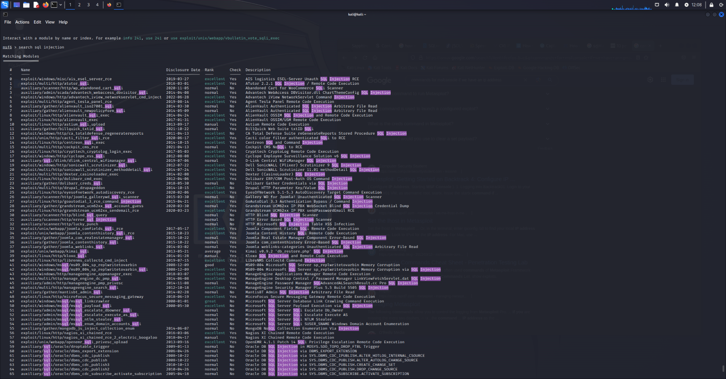

Figure 13: Searches in Metasploit

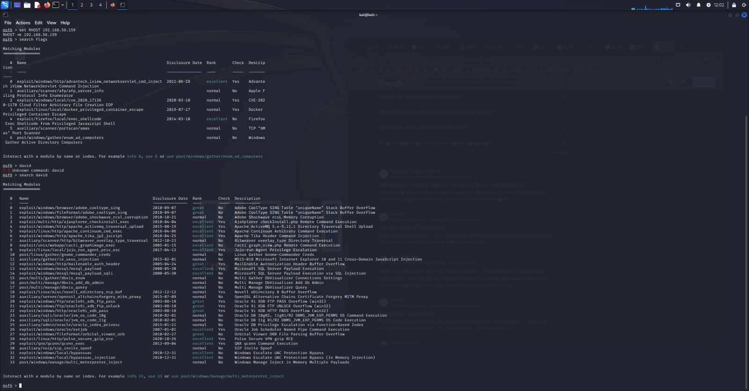

# Flag 4

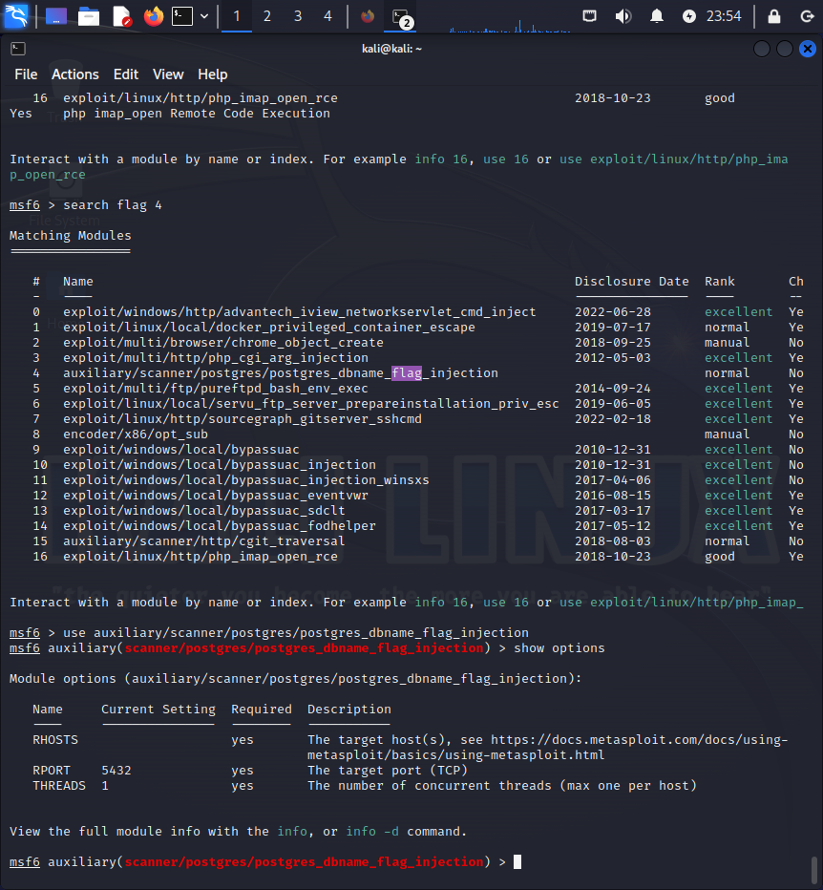

### Figure 18: Attempts to Search for Flag4 -

RPORT-5432, THREADS-1, Used- Auxiliary/scanner/postgres_dbname_flag_injection (Woltmann et al., 2021).

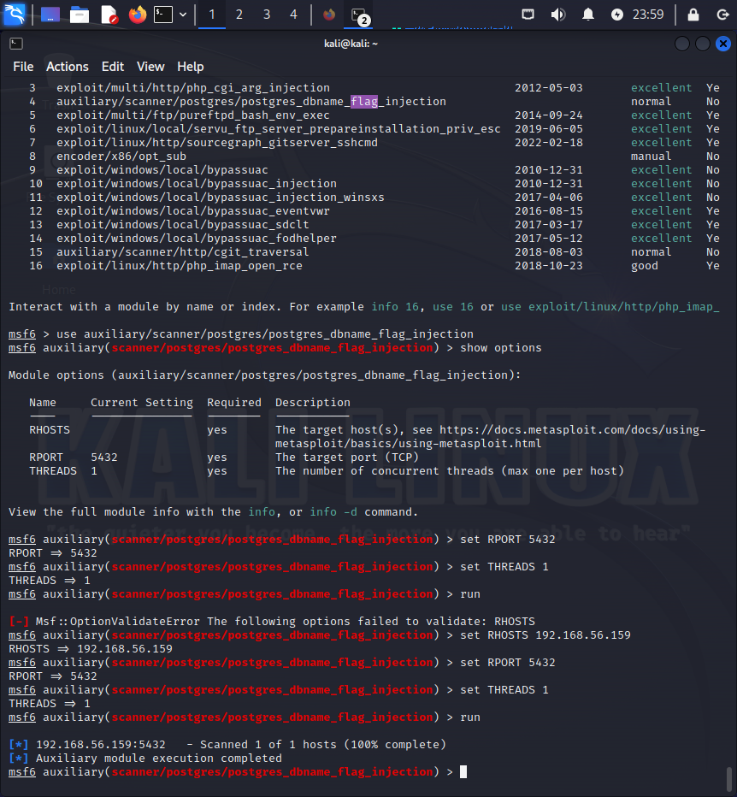

### Figure 19: Successfully scanned for SQL injection vulnerabilities

# Part 3 - Introducing Protection Mechanisms

## Vulnerability 1:

## PhpMyAdmin-

**Restrict Access to Trusted IP Addresses Only**

One effective strategy for securing phpMyAdmin is to restrict access to trusted IP addresses only. By limiting the IP addresses that can access phpMyAdmin, unauthorized users are prevented from exploiting vulnerabilities in the software. This can be achieved by configuring the web server or phpMyAdmin itself to allow access only from specific IP addresses. For instance, Apache's .htaccess file or Nginx's configuration file can be modified to include IP whitelisting rules (OWASP, 2022). This method significantly reduces the attack surface, ensuring that only authorized personnel can manage the database.

**Use Strong, Unique Passwords for All Database Users**

Ensuring that all database users employ strong, unique passwords is a fundamental security measure. Passwords should be complex, including a mix of upper- and lower-case letters, numbers, and special characters, and should not be easily guessable (Language-Based web session integrity, 2020). Additionally, implementing multi-factor authentication (MFA) can further enhance security by requiring a second form of verification beyond just the password. Regularly updating and rotating passwords can also help mitigate the risk of credential-based attacks (Language-Based web session integrity, 2020).

**Disable or Remove PhpMyAdmin if It Is Not Actively Used**

Another critical protection mechanism is to disable or remove phpMyAdmin if it is not actively used. Keeping unused software installed increases the potential attack surface unnecessarily (Karl et al., 2022). By removing or disabling phpMyAdmin, the risk associated with its vulnerabilities is eliminated (Karl et al., 2022). This practice aligns with the principle of least privilege, which advocates for minimizing the number of potential entry points for attackers (Karl et al., 2022). If phpMyAdmin must remain installed, it should be regularly updated to the latest version to ensure that any known security flaws are patched promptly (Karl et al., 2022).

## Vulnerability 2:

## CVE-2019-9517: A denial-of-service (DoS) vulnerability in HTTP/2.

**Consider Disabling HTTP/2 Support if It Is Not Required**

If HTTP/2 support is not necessary for the application, disabling it can prevent the exploitation of related vulnerabilities such as CVE-2019-9517. Disabling HTTP/2 can typically be done through the web server configuration. For instance, in Apache, this can be achieved by commenting out or removing the LoadModule http2_module modules/mod_http2.so line in the configuration file (Apache Documentation, 2023). This approach effectively mitigates the risk associated with this protocol while ensuring that the application continues to function using the more widely used HTTP/1.1 protocol.

**Ensure the Server Is Updated to a Version Where This Vulnerability Is Patched**

Regularly updating the server and all associated software to the latest versions is a critical defence against vulnerabilities (SPIDER: Enabling fast patch propagation in related software repositories, 2020). Many software vendors release patches and updates to address security flaws (SPIDER: Enabling fast patch propagation in related software repositories, 2020). Ensuring that these updates are applied promptly can protect against exploits that target known vulnerabilities (SPIDER: Enabling fast patch propagation in related software repositories, 2020). Automated update mechanisms or patch management solutions can help in maintaining up-to-date software versions, thereby reducing the risk of exploitation (*SPIDER: Enabling fast patch propagation in related software repositories*, 2020).

**Detailed Explanation of the Vulnerability**

Certain implementations of HTTP/2 suffer from a vulnerability that permits uncontrolled internal data buffering, potentially leading to a denial of service (Williams et al., 2020). In this scenario, an attacker can manipulate the HTTP/2 window to allow the peer to send data without restrictions while simultaneously keeping the TCP window closed, thereby preventing the peer from transmitting most of the bytes over the network (Williams et al., 2020). The attacker then initiates a series of requests for large response objects (Williams et al., 2020). Depending on how the server manages these queued responses, this can result in excessive consumption of memory and CPU resources, effectively leading to a denial of service (Williams et al., 2020).

**To defend against this vulnerability, administrators can employ several strategies:**

* Rate Limiting and Request Throttling: Implementing rate limiting and request throttling can help control the number of requests a server processes from a single client, thereby preventing abuse and potential denial-of-service attacks (Hasson, 2024).
* Resource Allocation and Isolation: Configuring servers to allocate and isolate resources more effectively can prevent any single user from consuming excessive memory or CPU resources. Containerization technologies, such as Docker, can be employed to isolate applications and manage resource limits more effectively ('Runtime options with Memory, CPUs, and GPUs,' 2024).

# Conclusion

The ethical hacking assessment of the Fernwood Clinic’s virtual machine revealed critical vulnerabilities, shedding light on the system's security. Following a systematic approach encompassing reconnaissance, scanning, exploitation, post-exploitation, and track covering, the assessment unearthed multiple open ports and services during the reconnaissance and scanning phases. Notably, Apache HTTP servers and a Webmin interface, running on outdated software versions, were identified as potential entry points. Key vulnerabilities included PhpMyAdmin and an HTTP/2 denial-of-service vulnerability (CVE-2019-9517), posing risks like unauthorized access and service disruptions.

Exploiting these vulnerabilities showcased their potential impact. Leveraging tools like Metasploit, the ethical hacker successfully retrieved several flags:

Flag 1: Extracted using a vulnerable WordPress plugin.

Flag 2: Vulnerability discovered but flag not retrieved from a compromised WordPress admin page.

Flag 3: Obtained through SQL injection on the database.

Flag 4 and Flag 5: Vulnerability identified via PostgreSQL injection exploiting an auxiliary scanner, flag not found. While not successfully exploited, a severe vulnerability was discovered on the Webmin site.

Post-exploitation activities involved installing backdoors and clearing logs, underlining the importance of robust monitoring and incident response protocols.

To mitigate these vulnerabilities, recommendations included restricting PhpMyAdmin access to trusted IP addresses, enforcing strong passwords, and disabling unnecessary services like HTTP/2. Regular software updates and strict firewall rules were also emphasized.

In conclusion, the assessment underscored the need for a comprehensive cybersecurity strategy at the Fernwood Clinic. Regular vulnerability assessments, continuous monitoring, and prompt security patches were deemed essential to safeguarding sensitive patient information and maintaining system integrity. Addressing the identified vulnerabilities and bolstering security protocols would enhance the clinic's resilience against cyber threats.

## References

1. Anchugam, C.V. (2021) 'Essential security elements and phases of hacking attacks,' in *Advances in information security, privacy, and ethics book series*, pp. 114–143. <https://doi.org/10.4018/978-1-7998-6504-9.ch010>.
2. *CVE website* (no date). <https://www.cve.org/CVERecord?id=CVE-2019-9517>.
3. Gunawan, T. S., Lim, M. K., Kartiwi, M., Malik, N. A., & Ismail, N. (2018). Penetration Testing using Kali Linux: SQL Injection, XSS, Wordpres, and WPA2 Attacks. Indonesian Journal of Electrical Engineering and Computer Science, 12(2), 729. https://doi.org/10.11591/ijeecs.v12.i2.pp729-737
4. Hasson, E. (2024) What is Rate Limiting | Types & Algorithms | Imperva. https://www.imperva.com/learn/application-security/rate-limiting/.
5. Kaur, R. *et al.* (2024) 'Bug Bounty recon automation using Bash scripting,' *Social Science Research Network* [Preprint]. <https://doi.org/10.2139/ssrn.4485337>.
6. Karl, M. et al. (2022) 'No keys to the kingdom required,' ACM [Preprint]. https://doi.org/10.1145/3517745.3561446.
7. Language-Based web session integrity (2020). https://ieeexplore.ieee.org/abstract/document/9155088.
8. mod_http2 - Apache HTTP Server Version 2.4 (no date). https://httpd.apache.org/docs/2.4/mod/mod_http2.html.
9. *OWASP Top Ten | OWASP Foundation* (no date). <https://owasp.org/www-project-top-ten/>.
10. NVD - CVE-2019-9517. (n.d.). https://nvd.nist.gov/vuln/detail/CVE-2019-9517
11. *'Runtime options with Memory, CPUs, and GPUs'* (2024). <https://docs.docker.com/config/containers/resource_constraints/>.
12. Runtime monitors to detect and prevent union query based SQL injection attacks. (2013, April 1). IEEE Conference Publication | IEEE Xplore. https://ieeexplore.ieee.org/abstract/document/6614334
13. Rekhter, Y. *et al.* (1996) *Address allocation for private internets*. <https://doi.org/10.17487/rfc1918>.
14. Saraswathi, V.R. *et al.* (2022) 'Automation of recon process for ethical hackers,' *2022 International Conference for Advancement in Technology (ICONAT)* [Preprint]. <https://doi.org/10.1109/iconat53423.2022.9726077>.
15. SPIDER: Enabling fast patch propagation in related software repositories (2020). https://ieeexplore.ieee.org/abstract/document/9152613.
16. Williams, M.A. et al. (2020) 'A vulnerability analysis and prediction framework,' Computers & Security, 92, p. 101751. <https://doi.org/10.1016/j.cose.2020.101751>.
17. Woltmann, L., Olwig, D., Hartmann, C., Habich, D., & Lehner, W. (2021). PostCENN. Proceedings of the VLDB Endowment, 14(12), 2715–2718. https://doi.org/10.14778/3476311.3476327